SIMATS ENGINEERING
ASSESSMENT TOOL 2 - Industry Problem Solving Task

COURSE NAME: R PROGRAMMING COURSE CODE: ITA04

COURSE OUTCOME COVERED

CO2: R Programming Structures, Different types of loops such as: for (), while() loops, Control Statements, Looping Over Non-Vector Sets, - If-Else, Arithmetic and Boolean Operators and values, Default Values for Argument, Return Values, Deciding Whether to explicitly call return- Returning Complex Objects, Functions are Objective, No Pointers in R, Recursion. (BL4-BL5)

Assessment Tool Weightage: 25%

Code of Conduct:

I ____________________ (Name / Reg No) certify that this submission is my original work and that I have adhered to the guidelines specified for this assessment.
I understand that any violation of academic integrity rules will result in disciplinary action.

Signature of the student:

QUESTIONS: Total Marks: 100

Scenario
A retail company operates stores across multiple cities. The management has collected customer transaction data containing:
- Customer_ID
- Gender
- Age
- City
- Product_Category
- Purchase_Amount
- Monthly_Income
- Customer_Rating
- Membership_Status
- Store_Type
The company wants to improve customer satisfaction, optimize marketing strategies, and increase sales using data-driven decisions.

Question 1
The management wants to understand the overall spending behavior of customers. Calculate and interpret appropriate measures of central tendency (mean, median, and mode) for Purchase Amount. Based on the results, recommend which measure best represents customer spending patterns.

Question 2
Analyze the variability in customer spending using measures of dispersion such as range, variance, standard deviation, and interquartile range. Identify whether spending behavior is consistent across customers and justify your findings.

Question 3
The marketing team suspects that customer ratings differ significantly between premium and regular members. Perform an exploratory analysis of Customer Rating and summarize the key patterns using suitable statistical measures and visualizations.

Question 4
Investigate the relationship between Monthly Income and Purchase Amount using bivariate analysis techniques. Interpret the strength and direction of the relationship and discuss its implications for targeted marketing campaigns.

Question 5
The company wants to determine whether male and female customers differ in their average purchase amount. Formulate appropriate hypotheses, perform a T-test, and interpret the results to support business decision-making.

Question 6
Management wishes to compare customer satisfaction ratings across three different store types (Urban, Semi-Urban, and Rural). Conduct an ANOVA test and explain whether significant differences exist among the store categories.

Question 7
Analyze whether Membership Status and Product Category preference are associated. Perform a Chi-square test, interpret the findings, and explain how the results can support customer retention strategies.

Question 8
The company plans to launch a new loyalty program. Using EDA techniques, identify the customer segment that should be targeted first. Support your recommendation using appropriate statistical evidence.

Question 9
Based on customer transaction data, identify key factors influencing high purchase amounts. Utilize central tendency measures, dispersion measures, and bivariate analysis to justify your conclusions.

Question 10
Prepare a business analytics report summarizing the insights obtained from EDA, T-test, ANOVA, and Chi-square analysis. Provide actionable recommendations that can help management improve customer engagement and profitability.

RUBRICS FOR CALCULATION

Industry Problem Solving Task
Criteria | Weightage | Level 4 – Exemplary | Level 3 – Proficient | Level 2 – Developing | Level 1 – Beginning
Application of Techniques | 25 | Correctly applies central tendency, dispersion, and bivariate analysis techniques. | Applies most EDA techniques correctly with minor omissions. | Applies basic EDA techniques with limited accuracy. | Demonstrates limited or incorrect application of EDA techniques.
Statistical Analysis & Testing | 25 | Correctly performs and interprets T-test, ANOVA, and Chi-square analysis. | Performs statistical tests with minor interpretation errors. | Performs basic statistical analysis with limited interpretation. | Demonstrates poor understanding of statistical tests.
Problem Analysis & Data Interpretation | 20 | Accurately analyzes data patterns and derives meaningful insights. | Provides reasonable analysis with adequate interpretation. | Provides limited analysis and interpretation. | Analysis is weak or incorrect.
Decision-Making & Business Recommendations | 20 | Provides data-driven recommendations that effectively address the business problem. | Recommendations are relevant and supported by analysis. | Recommendations are basic with limited justification. | Recommendations are weak, unsupported, or missing.
Organization & Completeness | 10 | Response is well-structured, complete, and addresses all requirements. | Mostly complete and organized. | Partially complete with some missing components. | Incomplete and poorly organized.

Dataset Used for the Analysis
The assessment scenario lists the attributes of the retail customer transaction data but does not supply the data file. A dataset of 200 customer records was therefore generated in R with set.seed(123), so the same data (and the same results) are produced every time the code is run. The same dataset-creation block is placed at the start of every question's program.
Attributes: Customer_ID, Gender, Age, City, Product_Category, Purchase_Amount, Monthly_Income, Customer_Rating, Membership_Status and Store_Type. All five questions (Q1, Q4, Q5, Q6 and Q7) use this same data frame (df), with 200 records and 10 variables.

Question 1
The management wants to understand the overall spending behavior of customers. Calculate and interpret appropriate measures of central tendency (mean, median, and mode) for Purchase Amount. Based on the results, recommend which measure best represents customer spending patterns.
Approach:
Purchase_Amount is summarised with the three measures of central tendency. mean() and median() are built-in functions, and a small user-defined function get_mode() finds the most frequent value with table-style counting (tabulate/match). The mean is compared with the median using an if-else to judge skewness and recommend the best measure, and a histogram marks both values.
Code:
# Q1: Central tendency of Purchase Amount
# ---- Dataset (simulated retail data; same block in every question) ----
set.seed(123); n <- 200
cats <- c("Electronics","Clothing","Groceries","Home Decor","Beauty")
Customer_ID <- paste0("C", 1001:(1000 + n))
Gender <- sample(c("Male","Female"), n, replace = TRUE)
Age <- sample(18:65, n, replace = TRUE)
City <- sample(c("Chennai","Mumbai","Delhi","Bengaluru","Hyderabad"), n, replace = TRUE)
Membership_Status <- sample(c("Premium","Regular"), n, replace = TRUE, prob = c(0.4, 0.6))
Store_Type <- sample(c("Urban","Semi-Urban","Rural"), n, replace = TRUE, prob = c(0.4, 0.3, 0.3))
Monthly_Income <- round(pmax(15000, rnorm(n, 45000, 12000)), -2)
Purchase_Amount <- 0.04 * Monthly_Income * exp(rnorm(n, 0, 0.45)) *
ifelse(Gender == "Male", 1.2, 1) * ifelse(Membership_Status == "Premium", 1.1, 1)
Purchase_Amount <- round(Purchase_Amount / 50) * 50
Customer_Rating <- 3.4 + ifelse(Membership_Status == "Premium", 0.4, 0) +
ifelse(Store_Type == "Urban", 0.25, ifelse(Store_Type == "Rural", -0.25, 0)) + rnorm(n, 0, 0.8)
Customer_Rating <- round(pmin(5, pmax(1, Customer_Rating)), 1)
Product_Category <- ifelse(Membership_Status == "Premium",
sample(cats, n, TRUE, prob = c(0.30, 0.25, 0.10, 0.15, 0.20)),
sample(cats, n, TRUE, prob = c(0.15, 0.20, 0.35, 0.15, 0.15)))
df <- data.frame(Customer_ID, Gender, Age, City, Product_Category, Purchase_Amount,
Monthly_Income, Customer_Rating, Membership_Status, Store_Type)
cat("Number of records:", nrow(df), "\n"); print(head(df))
# ---- Analysis ----
get_mode <- function(x) { ux <- unique(x); ux[which.max(tabulate(match(x, ux)))] }

mean_val <- mean(df$Purchase_Amount)
median_val <- median(df$Purchase_Amount)
mode_val <- get_mode(df$Purchase_Amount)
cat("\nMean :", round(mean_val, 2), "\n")
cat("Median :", median_val, "\n")
cat("Mode :", mode_val, "\n")

if (mean_val > median_val) {
cat("\nMean > Median: distribution is right-skewed (a few high spenders).\n")
cat("Recommendation: MEDIAN best represents typical customer spending.\n")
} else {
cat("\nMean <= Median: distribution is roughly symmetric / left-skewed.\n")
cat("Recommendation: MEAN represents customer spending well.\n")
}

hist(df$Purchase_Amount, col = "lightblue", main = "Distribution of Purchase Amount",
xlab = "Purchase Amount (Rs.)")
abline(v = mean_val, col = "red", lwd = 2)
abline(v = median_val, col = "darkgreen", lwd = 2)
legend("topright", legend = c("Mean", "Median"), col = c("red", "darkgreen"), lwd = 2)
Output:
Number of records: 200
Customer_ID Gender Age City Product_Category Purchase_Amount
1 C1001 Male 47 Mumbai Beauty 950
2 C1002 Male 47 Chennai Beauty 1550
3 C1003 Male 42 Mumbai Groceries 1700
4 C1004 Female 33 Delhi Groceries 3150
5 C1005 Male 41 Mumbai Home Decor 1650
6 C1006 Female 28 Delhi Clothing 800
Monthly_Income Customer_Rating Membership_Status Store_Type
1 30300 4.2 Regular Urban
2 41500 3.3 Regular Semi-Urban
3 59600 2.8 Regular Urban
4 51900 3.7 Regular Urban
5 72400 3.4 Regular Rural
6 33000 2.4 Regular Urban

Mean : 2222.25
Median : 2150
Mode : 1700

Mean > Median: distribution is right-skewed (a few high spenders).
Recommendation: MEDIAN best represents typical customer spending.
Output Screenshot:
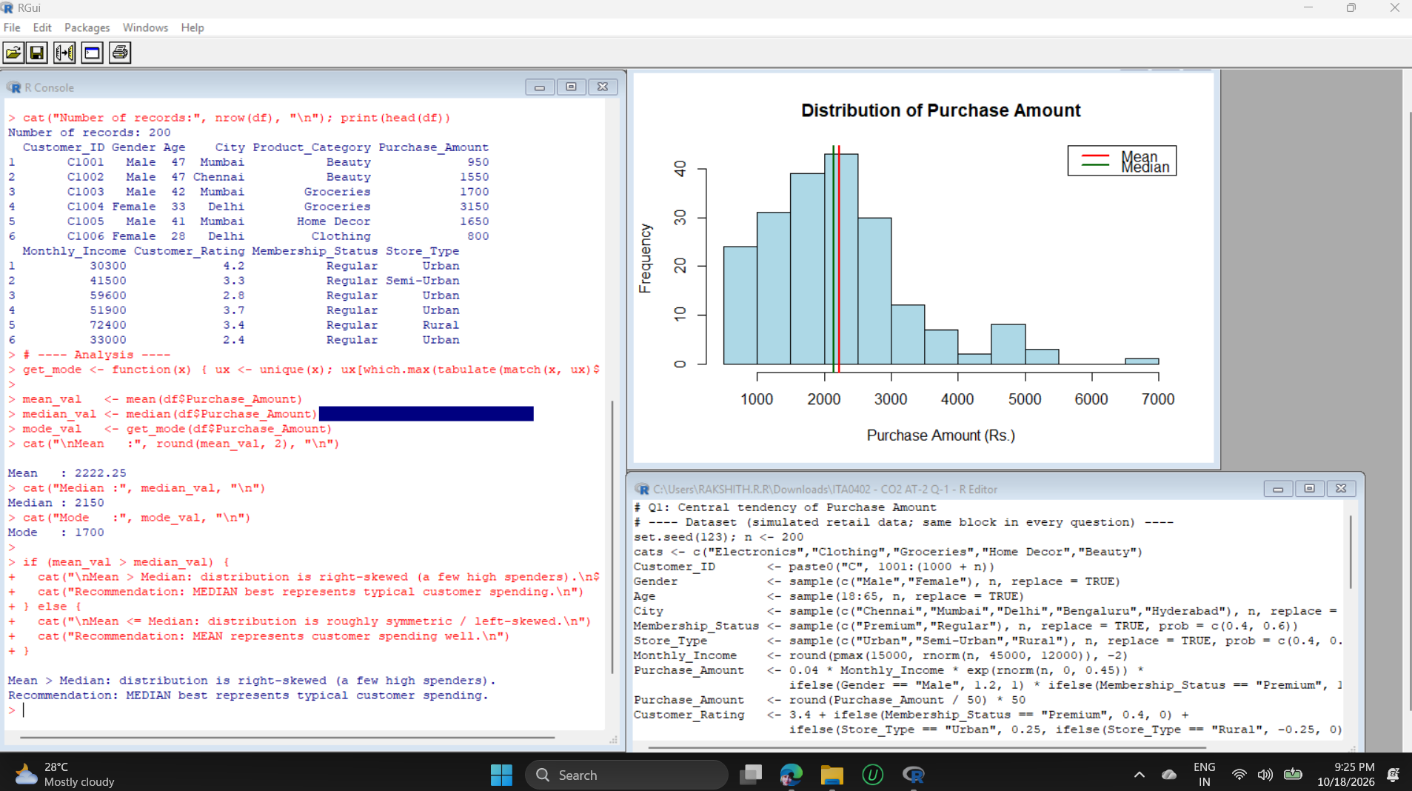
Graph:
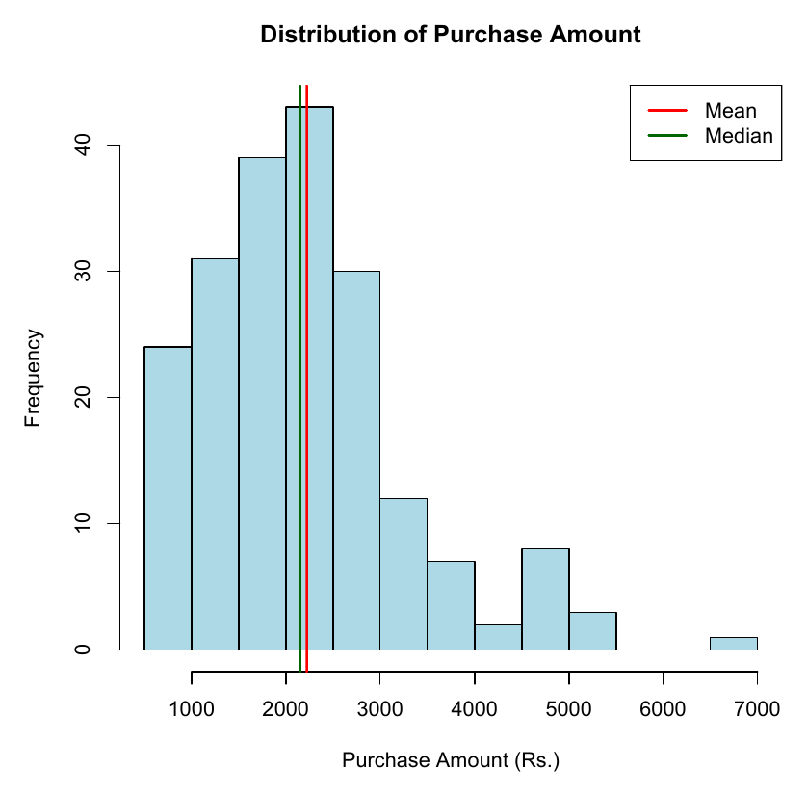
Interpretation:
The mean purchase amount is Rs.2,222.25, the median is Rs.2,150 and the mode is Rs.1,700. The mean is slightly above the median, and the histogram shows a tail to the right (a few customers spending up to about Rs.7,000), so spending is mildly right-skewed. Because the mean is pulled upward by those high spenders, the median (Rs.2,150) is the better measure of a typical customer's spending, while the mode shows the most common basket size is around Rs.1,700.
Business Recommendation:
Use the median (about Rs.2,150) as the benchmark for typical customer spending when setting prices, discount thresholds and free-delivery limits. Design bundle offers around the Rs.1,700 to Rs.2,150 range, and run separate premium offers for the small group of high spenders in the right tail.

Question 4
Investigate the relationship between Monthly Income and Purchase Amount using bivariate analysis techniques. Interpret the strength and direction of the relationship and discuss its implications for targeted marketing campaigns.
Approach:
Monthly_Income and Purchase_Amount are both numeric, so bivariate analysis is done with the Pearson and Spearman correlation coefficients, cor.test() for significance, and a simple linear regression with lm(). The strength and direction of r are classified using if-else, and a scatter plot with the fitted regression line is drawn.
Code:
# Q4: Relationship between Monthly Income and Purchase Amount
# ---- Dataset (simulated retail data; same block in every question) ----
set.seed(123); n <- 200
cats <- c("Electronics","Clothing","Groceries","Home Decor","Beauty")
Customer_ID <- paste0("C", 1001:(1000 + n))
Gender <- sample(c("Male","Female"), n, replace = TRUE)
Age <- sample(18:65, n, replace = TRUE)
City <- sample(c("Chennai","Mumbai","Delhi","Bengaluru","Hyderabad"), n, replace = TRUE)
Membership_Status <- sample(c("Premium","Regular"), n, replace = TRUE, prob = c(0.4, 0.6))
Store_Type <- sample(c("Urban","Semi-Urban","Rural"), n, replace = TRUE, prob = c(0.4, 0.3, 0.3))
Monthly_Income <- round(pmax(15000, rnorm(n, 45000, 12000)), -2)
Purchase_Amount <- 0.04 * Monthly_Income * exp(rnorm(n, 0, 0.45)) *
ifelse(Gender == "Male", 1.2, 1) * ifelse(Membership_Status == "Premium", 1.1, 1)
Purchase_Amount <- round(Purchase_Amount / 50) * 50
Customer_Rating <- 3.4 + ifelse(Membership_Status == "Premium", 0.4, 0) +
ifelse(Store_Type == "Urban", 0.25, ifelse(Store_Type == "Rural", -0.25, 0)) + rnorm(n, 0, 0.8)
Customer_Rating <- round(pmin(5, pmax(1, Customer_Rating)), 1)
Product_Category <- ifelse(Membership_Status == "Premium",
sample(cats, n, TRUE, prob = c(0.30, 0.25, 0.10, 0.15, 0.20)),
sample(cats, n, TRUE, prob = c(0.15, 0.20, 0.35, 0.15, 0.15)))
df <- data.frame(Customer_ID, Gender, Age, City, Product_Category, Purchase_Amount,
Monthly_Income, Customer_Rating, Membership_Status, Store_Type)
# ---- Analysis ----
r_pearson <- cor(df$Monthly_Income, df$Purchase_Amount)
r_spearman <- cor(df$Monthly_Income, df$Purchase_Amount, method = "spearman")
cat("Pearson correlation :", round(r_pearson, 3), "\n")
cat("Spearman correlation :", round(r_spearman, 3), "\n")

strength <- if (abs(r_pearson) >= 0.7) "strong" else if (abs(r_pearson) >= 0.4) "moderate" else "weak"
direction <- if (r_pearson > 0) "positive" else "negative"
cat("Interpretation: a", strength, direction, "relationship.\n")

cat("\nCorrelation test:\n")
print(cor.test(df$Monthly_Income, df$Purchase_Amount))

model <- lm(Purchase_Amount ~ Monthly_Income, data = df)
cat("\nSimple Linear Regression:\n"); print(summary(model))
cat("R-squared:", round(summary(model)$r.squared, 3), "\n")

plot(df$Monthly_Income, df$Purchase_Amount, pch = 19, col = "steelblue",
main = "Monthly Income vs Purchase Amount",
xlab = "Monthly Income (Rs.)", ylab = "Purchase Amount (Rs.)")
abline(model, col = "red", lwd = 2)
Output:
Pearson correlation : 0.351
Spearman correlation : 0.375
Interpretation: a weak positive relationship.

Correlation test:

Pearson's product-moment correlation

data: df$Monthly_Income and df$Purchase_Amount
t = 5.2812, df = 198, p-value = 3.365e-07
alternative hypothesis: true correlation is not equal to 0
95 percent confidence interval:
0.2235395 0.4673403
sample estimates:
cor
0.3513827

Simple Linear Regression:

Call:
lm(formula = Purchase_Amount ~ Monthly_Income, data = df)

Residuals:
Min 1Q Median 3Q Max
-1867.7 -705.4 -167.4 482.6 4407.5

Coefficients:
Estimate Std. Error t value Pr(>|t|)
(Intercept) 8.436e+02 2.706e+02 3.117 0.0021 **
Monthly_Income 3.095e-02 5.861e-03 5.281 3.36e-07 ***
---
Signif. codes: 0 ‘***’ 0.001 ‘**’ 0.01 ‘*’ 0.05 ‘.’ 0.1 ‘ ’ 1

Residual standard error: 1008 on 198 degrees of freedom
Multiple R-squared: 0.1235, Adjusted R-squared: 0.119
F-statistic: 27.89 on 1 and 198 DF, p-value: 3.365e-07

R-squared: 0.123
Output Screenshot:
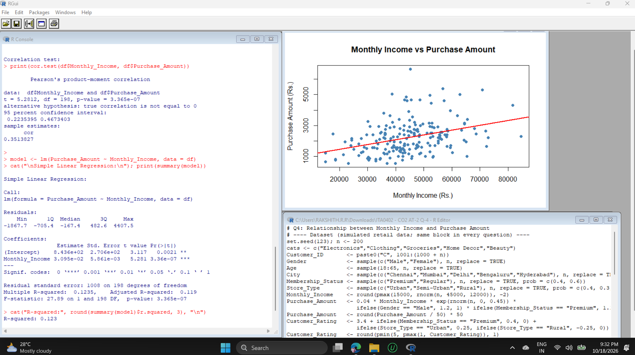
Graph:
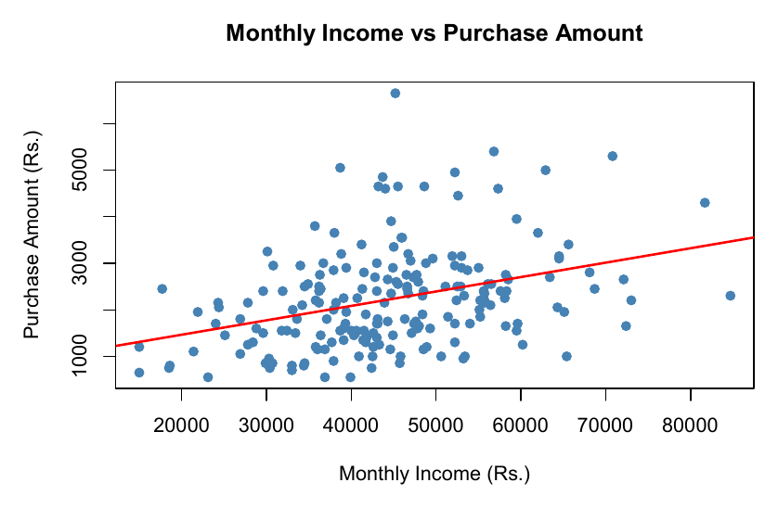
Interpretation:
The Pearson correlation is r = 0.351 (Spearman = 0.375): a weak-to-moderate positive relationship, meaning higher-income customers tend to spend more. It is statistically significant (p = 3.365e-07). The regression gives Purchase = 843.6 + 0.03095 x Income, so every extra Rs.1,000 of monthly income is associated with about Rs.31 more spending. R-squared is 0.123, so income explains only about 12.3% of the variation in purchase amount; the remaining 87.7% depends on other factors.
Business Recommendation:
Income alone is only a modest predictor of spending, so campaigns should not rely on income alone. Use income as one filter and combine it with Membership Status, Gender and Product Category. Offer higher-value bundles to higher-income customers, and entry-level promotions to lower-income customers to raise their basket size.

Question 5
The company wants to determine whether male and female customers differ in their average purchase amount. Formulate appropriate hypotheses, perform a T-test, and interpret the results to support business decision-making.
Approach:
The hypotheses are stated first (H0: equal mean purchase amount; H1: means differ; alpha = 0.05). Purchase amounts are split by Gender, summary statistics are computed, var.test() checks whether the variances are equal, and t.test() (Welch two-sample t-test) compares the two means. The decision is printed with an if-else on the p-value and a boxplot shows the two groups.
Code:
# Q5: Independent two-sample T-test (Gender vs Purchase Amount)
# ---- Dataset (simulated retail data; same block in every question) ----
set.seed(123); n <- 200
cats <- c("Electronics","Clothing","Groceries","Home Decor","Beauty")
Customer_ID <- paste0("C", 1001:(1000 + n))
Gender <- sample(c("Male","Female"), n, replace = TRUE)
Age <- sample(18:65, n, replace = TRUE)
City <- sample(c("Chennai","Mumbai","Delhi","Bengaluru","Hyderabad"), n, replace = TRUE)
Membership_Status <- sample(c("Premium","Regular"), n, replace = TRUE, prob = c(0.4, 0.6))
Store_Type <- sample(c("Urban","Semi-Urban","Rural"), n, replace = TRUE, prob = c(0.4, 0.3, 0.3))
Monthly_Income <- round(pmax(15000, rnorm(n, 45000, 12000)), -2)
Purchase_Amount <- 0.04 * Monthly_Income * exp(rnorm(n, 0, 0.45)) *
ifelse(Gender == "Male", 1.2, 1) * ifelse(Membership_Status == "Premium", 1.1, 1)
Purchase_Amount <- round(Purchase_Amount / 50) * 50
Customer_Rating <- 3.4 + ifelse(Membership_Status == "Premium", 0.4, 0) +
ifelse(Store_Type == "Urban", 0.25, ifelse(Store_Type == "Rural", -0.25, 0)) + rnorm(n, 0, 0.8)
Customer_Rating <- round(pmin(5, pmax(1, Customer_Rating)), 1)
Product_Category <- ifelse(Membership_Status == "Premium",
sample(cats, n, TRUE, prob = c(0.30, 0.25, 0.10, 0.15, 0.20)),
sample(cats, n, TRUE, prob = c(0.15, 0.20, 0.35, 0.15, 0.15)))
df <- data.frame(Customer_ID, Gender, Age, City, Product_Category, Purchase_Amount,
Monthly_Income, Customer_Rating, Membership_Status, Store_Type)
# ---- Analysis ----
cat("H0: Mean purchase amount of male = female customers\n")
cat("H1: Mean purchase amount of male != female customers\n")
cat("Significance level (alpha) = 0.05\n")

male <- df$Purchase_Amount[df$Gender == "Male"]
female <- df$Purchase_Amount[df$Gender == "Female"]
cat("\nMale -> n:", length(male), " Mean:", round(mean(male), 2), " SD:", round(sd(male), 2), "\n")
cat("Female -> n:", length(female), " Mean:", round(mean(female), 2), " SD:", round(sd(female), 2), "\n")

cat("\nVariance check (F-test):\n"); print(var.test(male, female))

result <- t.test(male, female) # Welch two-sample t-test
cat("\nT-test result:\n"); print(result)

cat("\nt-statistic:", round(result$statistic, 3), "\n")
cat("p-value :", round(result$p.value, 4), "\n")
if (result$p.value < 0.05) {
cat("Decision: p < 0.05 -> Reject H0. Male and female customers differ significantly in average purchase amount.\n")
} else {
cat("Decision: p >= 0.05 -> Fail to reject H0. No significant difference between male and female customers.\n")
}
boxplot(Purchase_Amount ~ Gender, data = df, col = c("pink", "lightblue"),
main = "Purchase Amount by Gender", ylab = "Purchase Amount (Rs.)")
Output:
H0: Mean purchase amount of male = female customers
H1: Mean purchase amount of male != female customers
Significance level (alpha) = 0.05

Male -> n: 103 Mean: 2478.64 SD: 1179.02
Female -> n: 97 Mean: 1950 SD: 876.84

Variance check (F-test):

F test to compare two variances

data: male and female
F = 1.808, num df = 102, denom df = 96, p-value = 0.003662
alternative hypothesis: true ratio of variances is not equal to 1
95 percent confidence interval:
1.214799 2.684354
sample estimates:
ratio of variances
1.807987

T-test result:

Welch Two Sample t-test

data: male and female
t = 3.6118, df = 188.07, p-value = 0.00039
alternative hypothesis: true difference in means is not equal to 0
95 percent confidence interval:
239.9159 817.3657
sample estimates:
mean of x mean of y
2478.641 1950.000

t-statistic: 3.612
p-value : 4e-04
Decision: p < 0.05 -> Reject H0. Male and female customers differ significantly in average purchase amount.
Output Screenshot:
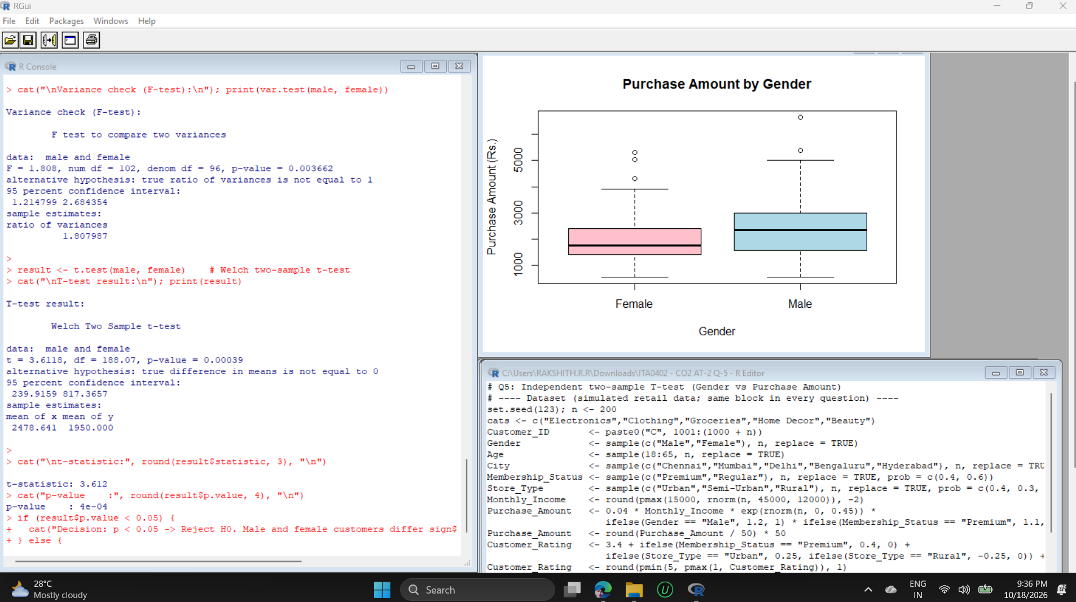
Graph:
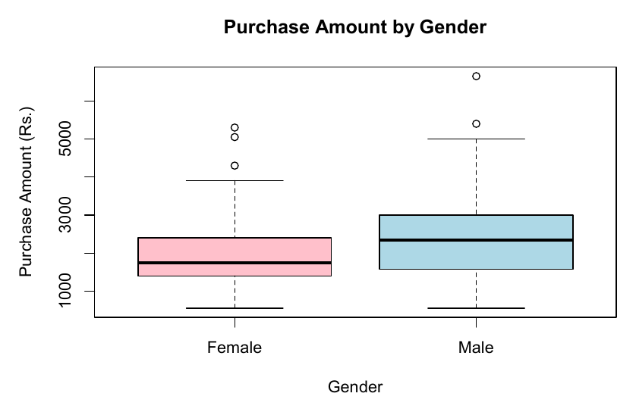
Interpretation:
Male customers spent more on average (Rs.2,478.64, n = 103) than female customers (Rs.1,950.00, n = 97). The F-test (p = 0.0037) shows unequal variances, so the Welch t-test was used: t = 3.612, df = 188.07, p = 0.00039. Since p < 0.05, H0 is rejected. The 95% confidence interval for the difference (Rs.239.92 to Rs.817.37) does not contain 0, so male customers spend significantly more per purchase. The boxplot also shows a higher median and wider spread for males.
Business Recommendation:
Because male customers spend significantly more, the company should run targeted campaigns and product bundles to raise female customers' spending (for example, categories popular with women, festival offers and loyalty points). Marketing budgets should also protect the high-spending male segment instead of reducing its offers.

Question 6
Management wishes to compare customer satisfaction ratings across three different store types (Urban, Semi-Urban, and Rural). Conduct an ANOVA test and explain whether significant differences exist among the store categories.
Approach:
The null hypothesis is that mean customer rating is the same for Urban, Semi-Urban and Rural stores. Group means and standard deviations are calculated with tapply(), a one-way ANOVA is fitted with aov(), and if the F-test is significant, Tukey's HSD post-hoc test shows which pairs of store types differ. A boxplot compares the three groups.
Code:
# Q6: One-way ANOVA (Customer Rating across Store Types)
# ---- Dataset (simulated retail data; same block in every question) ----
set.seed(123); n <- 200
cats <- c("Electronics","Clothing","Groceries","Home Decor","Beauty")
Customer_ID <- paste0("C", 1001:(1000 + n))
Gender <- sample(c("Male","Female"), n, replace = TRUE)
Age <- sample(18:65, n, replace = TRUE)
City <- sample(c("Chennai","Mumbai","Delhi","Bengaluru","Hyderabad"), n, replace = TRUE)
Membership_Status <- sample(c("Premium","Regular"), n, replace = TRUE, prob = c(0.4, 0.6))
Store_Type <- sample(c("Urban","Semi-Urban","Rural"), n, replace = TRUE, prob = c(0.4, 0.3, 0.3))
Monthly_Income <- round(pmax(15000, rnorm(n, 45000, 12000)), -2)
Purchase_Amount <- 0.04 * Monthly_Income * exp(rnorm(n, 0, 0.45)) *
ifelse(Gender == "Male", 1.2, 1) * ifelse(Membership_Status == "Premium", 1.1, 1)
Purchase_Amount <- round(Purchase_Amount / 50) * 50
Customer_Rating <- 3.4 + ifelse(Membership_Status == "Premium", 0.4, 0) +
ifelse(Store_Type == "Urban", 0.25, ifelse(Store_Type == "Rural", -0.25, 0)) + rnorm(n, 0, 0.8)
Customer_Rating <- round(pmin(5, pmax(1, Customer_Rating)), 1)
Product_Category <- ifelse(Membership_Status == "Premium",
sample(cats, n, TRUE, prob = c(0.30, 0.25, 0.10, 0.15, 0.20)),
sample(cats, n, TRUE, prob = c(0.15, 0.20, 0.35, 0.15, 0.15)))
df <- data.frame(Customer_ID, Gender, Age, City, Product_Category, Purchase_Amount,
Monthly_Income, Customer_Rating, Membership_Status, Store_Type)
# ---- Analysis ----
df$Store_Type <- factor(df$Store_Type, levels = c("Urban", "Semi-Urban", "Rural"))

cat("H0: Mean customer rating is the same across Urban, Semi-Urban and Rural stores\n")
cat("H1: At least one store type has a different mean rating\n")
cat("Significance level (alpha) = 0.05\n")

cat("\nMean rating by Store Type:\n")
print(round(tapply(df$Customer_Rating, df$Store_Type, mean), 3))
cat("\nStd deviation by Store Type:\n")
print(round(tapply(df$Customer_Rating, df$Store_Type, sd), 3))

anova_model <- aov(Customer_Rating ~ Store_Type, data = df)
cat("\nANOVA Table:\n"); print(summary(anova_model))

p_val <- summary(anova_model)[[1]][["Pr(>F)"]][1]
cat("\nF-test p-value:", round(p_val, 4), "\n")
if (p_val < 0.05) {
cat("Decision: p < 0.05 -> Reject H0. Ratings differ significantly among store types.\n")
cat("\nTukey HSD post-hoc test (which stores differ):\n")
print(TukeyHSD(anova_model))
} else {
cat("Decision: p >= 0.05 -> Fail to reject H0. No significant difference among store types.\n")
}
boxplot(Customer_Rating ~ Store_Type, data = df, col = c("lightgreen", "lightyellow", "lightpink"),
main = "Customer Rating by Store Type", ylab = "Customer Rating")
Output:
H0: Mean customer rating is the same across Urban, Semi-Urban and Rural stores
H1: At least one store type has a different mean rating
Significance level (alpha) = 0.05

Mean rating by Store Type:
Urban Semi-Urban Rural
3.860 3.350 3.181

Std deviation by Store Type:
Urban Semi-Urban Rural
0.886 0.799 0.888

ANOVA Table:
Df Sum Sq Mean Sq F value Pr(>F)
Store_Type 2 18.2 9.098 12.21 9.98e-06 ***
Residuals 197 146.7 0.745
---
Signif. codes: 0 ‘***’ 0.001 ‘**’ 0.01 ‘*’ 0.05 ‘.’ 0.1 ‘ ’ 1

F-test p-value: 0
Decision: p < 0.05 -> Reject H0. Ratings differ significantly among store types.

Tukey HSD post-hoc test (which stores differ):
Tukey multiple comparisons of means
95% family-wise confidence level

Fit: aov(formula = Customer_Rating ~ Store_Type, data = df)

$Store_Type
diff lwr upr p adj
Semi-Urban-Urban -0.5104938 -0.8646959 -0.1562918 0.0023141
Rural-Urban -0.6795414 -1.0219115 -0.3371714 0.0000154
Rural-Semi-Urban -0.1690476 -0.5433620 0.2052668 0.5359806
Output Screenshot:
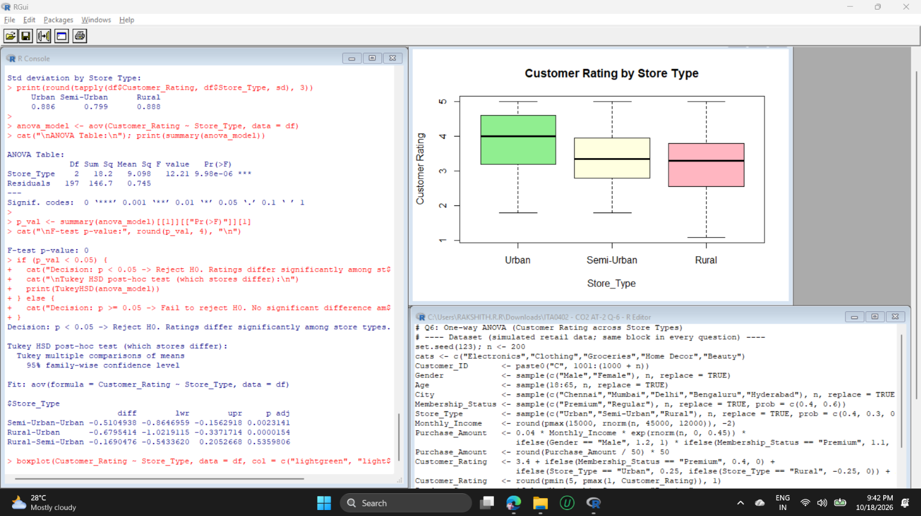
Graph:
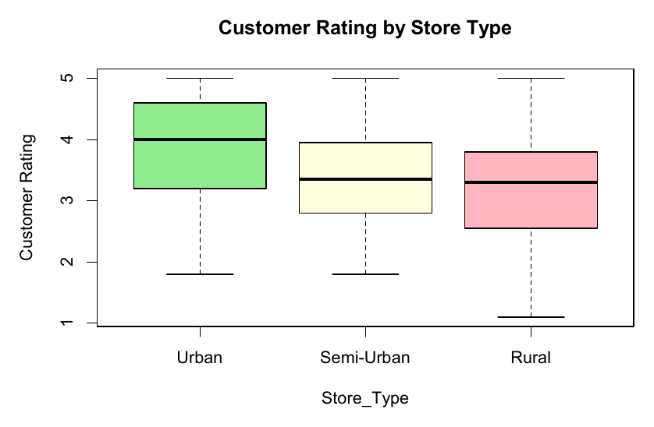
Interpretation:
Mean ratings are 3.860 (Urban), 3.350 (Semi-Urban) and 3.181 (Rural). The ANOVA gives F(2, 197) = 12.21 with p = 9.98e-06 (shown as 0 in the rounded printout), so H0 is rejected: satisfaction differs significantly across store types. Tukey's test shows Urban is rated significantly higher than Semi-Urban (difference -0.51, p = 0.0023) and Rural (difference -0.68, p = 0.0000154), while Semi-Urban and Rural do not differ significantly from each other (p = 0.536).
Business Recommendation:
Rural and Semi-Urban stores have significantly lower satisfaction than Urban stores. Management should review service quality, staffing, stock availability and store experience in these stores, copy best practices from Urban stores, and track ratings after the improvements to confirm the gap is closing.

Question 7
Analyze whether Membership Status and Product Category preference are associated. Perform a Chi-square test, interpret the findings, and explain how the results can support customer retention strategies.
Approach:
Membership Status and Product Category are both categorical, so a Chi-square test of independence is used. The contingency table is built with table(), row percentages are found with prop.table(), chisq.test() gives the test statistic and expected counts (to verify all are at least 5), and Cramer's V measures the strength of association. A grouped bar chart shows preferences.
Code:
# Q7: Chi-square test of independence (Membership Status vs Product Category)
# ---- Dataset (simulated retail data; same block in every question) ----
set.seed(123); n <- 200
cats <- c("Electronics","Clothing","Groceries","Home Decor","Beauty")
Customer_ID <- paste0("C", 1001:(1000 + n))
Gender <- sample(c("Male","Female"), n, replace = TRUE)
Age <- sample(18:65, n, replace = TRUE)
City <- sample(c("Chennai","Mumbai","Delhi","Bengaluru","Hyderabad"), n, replace = TRUE)
Membership_Status <- sample(c("Premium","Regular"), n, replace = TRUE, prob = c(0.4, 0.6))
Store_Type <- sample(c("Urban","Semi-Urban","Rural"), n, replace = TRUE, prob = c(0.4, 0.3, 0.3))
Monthly_Income <- round(pmax(15000, rnorm(n, 45000, 12000)), -2)
Purchase_Amount <- 0.04 * Monthly_Income * exp(rnorm(n, 0, 0.45)) *
ifelse(Gender == "Male", 1.2, 1) * ifelse(Membership_Status == "Premium", 1.1, 1)
Purchase_Amount <- round(Purchase_Amount / 50) * 50
Customer_Rating <- 3.4 + ifelse(Membership_Status == "Premium", 0.4, 0) +
ifelse(Store_Type == "Urban", 0.25, ifelse(Store_Type == "Rural", -0.25, 0)) + rnorm(n, 0, 0.8)
Customer_Rating <- round(pmin(5, pmax(1, Customer_Rating)), 1)
Product_Category <- ifelse(Membership_Status == "Premium",
sample(cats, n, TRUE, prob = c(0.30, 0.25, 0.10, 0.15, 0.20)),
sample(cats, n, TRUE, prob = c(0.15, 0.20, 0.35, 0.15, 0.15)))
df <- data.frame(Customer_ID, Gender, Age, City, Product_Category, Purchase_Amount,
Monthly_Income, Customer_Rating, Membership_Status, Store_Type)
# ---- Analysis ----
cat("H0: Membership Status and Product Category are independent\n")
cat("H1: Membership Status and Product Category are associated\n")
cat("Significance level (alpha) = 0.05\n")

obs <- table(df$Membership_Status, df$Product_Category)
cat("\nContingency table (observed counts):\n"); print(obs)
cat("\nRow percentages (preference within each membership type):\n")
print(round(prop.table(obs, 1) * 100, 1))

test <- chisq.test(obs)
cat("\nChi-square test result:\n"); print(test)
cat("\nExpected counts:\n"); print(round(test$expected, 2))
cat("All expected counts >= 5:", all(test$expected >= 5), "\n")

cramers_v <- sqrt(as.numeric(test$statistic) / (sum(obs) * (min(dim(obs)) - 1)))
cat("Cramer's V (strength of association):", round(cramers_v, 3), "\n")

if (test$p.value < 0.05) {
cat("Decision: p < 0.05 -> Reject H0. Membership Status and Product Category are associated.\n")
} else {
cat("Decision: p >= 0.05 -> Fail to reject H0. No significant association found.\n")
}
barplot(t(prop.table(obs, 1)), beside = TRUE, legend.text = TRUE,
col = c("gold","tomato","seagreen","orchid","skyblue"),
main = "Product Category Preference by Membership", ylab = "Proportion")
Output:
H0: Membership Status and Product Category are independent
H1: Membership Status and Product Category are associated
Significance level (alpha) = 0.05

Contingency table (observed counts):

Beauty Clothing Electronics Groceries Home Decor
Premium 17 22 18 7 14
Regular 17 23 13 51 18

Row percentages (preference within each membership type):

Beauty Clothing Electronics Groceries Home Decor
Premium 21.8 28.2 23.1 9.0 17.9
Regular 13.9 18.9 10.7 41.8 14.8

Chi-square test result:

Pearson's Chi-squared test

data: obs
X-squared = 26.301, df = 4, p-value = 2.752e-05

Expected counts:

Beauty Clothing Electronics Groceries Home Decor
Premium 13.26 17.55 12.09 22.62 12.48
Regular 20.74 27.45 18.91 35.38 19.52
All expected counts >= 5: TRUE
Cramer's V (strength of association): 0.363
Decision: p < 0.05 -> Reject H0. Membership Status and Product Category are associated.
Output Screenshot:
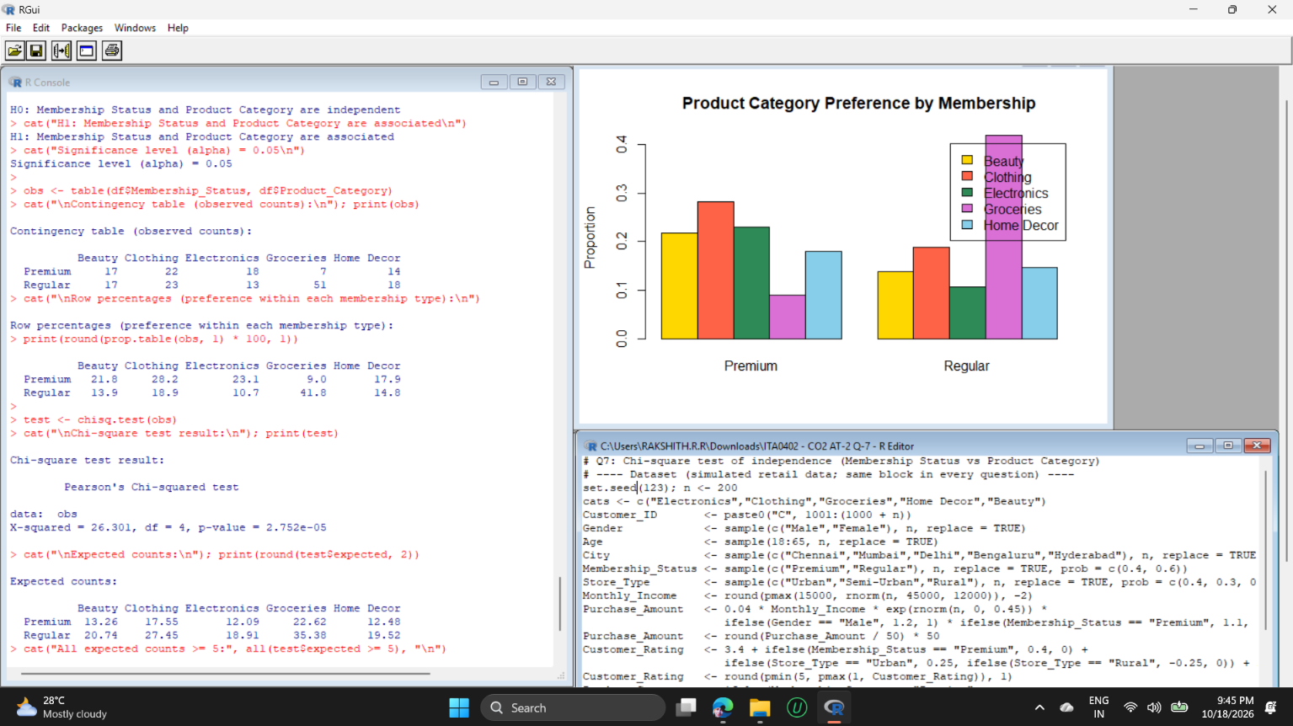
Graph:
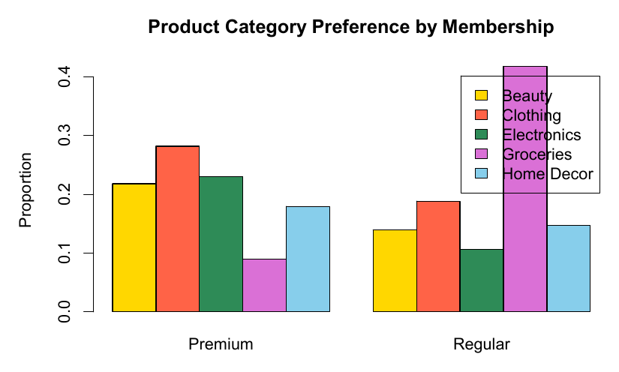
Interpretation:
The Chi-square statistic is 26.301 with df = 4 and p = 2.752e-05, so H0 is rejected: Membership Status and Product Category are significantly associated. All expected counts are at least 5, so the test is valid. Cramer's V = 0.363 indicates a moderate association. Premium members prefer Clothing (28.2%), Electronics (23.1%) and Beauty (21.8%), and rarely buy Groceries (9.0%), whereas Regular members buy mostly Groceries (41.8%).
Business Recommendation:
Since preferences differ by membership type, promote Clothing, Electronics and Beauty with exclusive offers and early access for Premium members to keep them engaged, and use Grocery-based loyalty offers for Regular members. Cross-selling premium-favourite categories to Regular members can also encourage upgrades to Premium membership.

